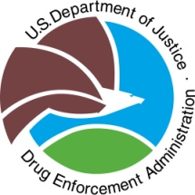 National Take Back Initiative
April 29, 2017
10:00 a.m.-2:00 p.m.

Registration Form

Participant Information

Law Enforcement Agency: ____________________________________

Point of Contact Name: _______________________________________
Address: _____________________________________
_______________________________________
_______________________________________
Phone: _______________________________________
Email: _______________________________________

Collection Site: ______________________________________________
Address: ______________________________________________
City: _______________ State: _________ Zip: __________

In order for DEA to obtain the necessary supplies for your Agency to participate, please respond via fax
or scanning and emailing this form by March 1, 2017.
______________________________________________________________________________________________________________________________________________________________________________________________________________________________________________________________________________

DEA Contact Information

Point of Contact Name: Lisa Sullivan
Address: 10160 Technology Blvd., East Dallas, Texas 75220

Phone: 214.366.6936
Fax: 214.366.6902
Email: Lisa.d.Sullivan@usdoj.gov

